**Documentation of the SearchPage design**

**General information:**

Background color: █ 163E3D

Text color: █ 000000

Highlighted text color : █ F50A0A

Date and time underlining in links. █ F5A200

Text color in green background: ☐ FFFFFF

Borders of the links and navigation bar: █ 7BC7AB

Colors of the icons in navigation bar: ☐ FFFFFF

Main font: Open Sans

**Navigation bar:**

* The icon in the upper left corner opens the navigation menu.
* In the middle is the Geocache.fi logo
* The icon in the upper right corner opens the login/registration page or, if you are already logged in, a view of your account information.

**Search bar with filters:**

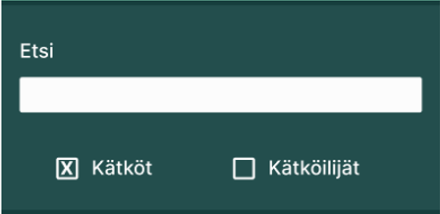

Background color: █ 234E4D

Text color: ☐

Text font: Open Sans

* Search page with results will open when the user complete first search from the main menu.
* Search will start by pressing the "enter" key on keyboard.
* There are two search attributes “Kätköt” ja “Kätköilijät” (Caches and Cachers) which you can choose from which areas to search from, if neither is selected, both areas will be included.
* When you start typing in the search field, predictive text input suggests possible search words.

**Body of the website:**

**Links:**

Cache:

* Cache icon, several different types. By pressing the icon, only the logs of that cache can be selected for display.
* Time and date, if the cache was added less than an hour ago, the minutes from when the cache was added are displayed highlighted in red. In caches older than this, the date and time are displayed.
* The name of the cache also serves as a link to the cache's own page with more detailed information.
* The distance of the cache from the starting point defined by the user. If the cache is closer than the limit defined by the user, the distance is highlighted in red.
* The municipality in which the cache is located.

Logo and a link to the www.geocaching.com site

Web address of the logo <https://www.geocache.fi/images/Geocaching_API_Logo_vCOMP2_090716_LRG.png>

Footer

Attached in the document are the pictures from the front page in whole size and in screen size

